|  |
| --- |
| **IT703**  **Database Design and Implementation** |



**Faculty of Health, Humanities and Computing**

**Tutor: Abdul Rehman**

[**abdul.rehman@sit.ac.nz**](mailto:abdul.rehman@sit.ac.nz)

**Assignment 2**

|  |  |
| --- | --- |
| Due Date/Time:  Total Marks: | Wednesday 30 Oct 2019  Mid Night  30 (30% of this paper) |

**Learning Outcomes**

* Implement various database-driven applications
* Develop applications using RAD technologies with 3GLs and 4GLs
* Exchange data between the application and other software

**Instructions:**

1. This is a group assignment (a group of maximum 3).

2. Submission of this assignment will be electronic only. Upload the electronic copy of this assignment to the course Blackboard site.

3. The assignment submitted after the due date and time without having received an extension from the tutor and or the programme manager in extreme circumstances will be penalised according to the following:

* **10%** of marks deducted if submitted within 24hrs of the deadline
* **20%** of marks deducted if submitted after 24hrs and up to 48hrs of the deadline
* **30%** of marks deducted if submitted after 48hrs and up to 72hrs of the deadline
* No grade will be awarded for an assignment submitted later than 72hrs after the deadline.

4. The assignment after the due date and time will be ineligible to resubmit a failed assignment.

5. You must attach the coversheet (provided at the end of this document) to the front of your submission with the marking schedule for me to record your marks.

6. Document all the deliverables and also you should be able to demonstrate your work.

7. Please note any plagiarism will be dealt with in accordance with the Institute’s policies. This may result in severely curtailed (or zero) marks. You will learn nothing (and score nothing) by copying others’ work

**Deliverables:**

Your team has been asked to develop a new web-based application for a hotel chain to be commissioned immediately by the Tomive Corporation. Your application will be tested in the first hotel to be completed and must be running bug-free before it will be accepted for the rest of the chain.

The user interface must be user-friendly and it is important to have a well-designed interface.

**Business Rules:**

The business uses these colours and would like to theme the software with them

**A customer**

Can make multiple bookings

Can make bookings for multiple days

Can book a carpark

Can Pay by cash, EFTPOS, voucher or credit card

Must use a Credit card/ debit card to make a booking

Can chargeback from restaurants

Store customer details and notes/preferences

Can attach a company or travel agency or both to the customer

Show if payment/deposit was made and how it was paid (online, cash etc.)

How they booked

Where they are from

May use a booking reference number

**Rooms**

There are three room types single (max two occupants), two bedrooms (max four occupants) and superior (max two occupants)

Have five statuses vacant clean, vacant dirty, occupied clean, occupied service, on maintenance

A car park is assigned to a customer

Message alerts for customers

**Users with logins**

Three levels

*Manager*

* Can set up new users and privileges
* Run end of day reports, booking forecasts
* Bookings, check in’s and checkouts.
* Bill to date
* Housekeeping reports
* Maintenance
* Daily backup

*Reception*

* Run end of day reports, booking forecasts
* Bookings, check in’s and checkouts.
* Housekeeping reports
* Maintenance
* Daily backup

*Housekeeper*

* Housekeeping reports
* Change room status
* Maintenance

**Reports (print to screen)**

End of day (check in’s check out’s. money in/out)

In house report (guests in-house)

Housekeeping report (rooms to clean/service and check incoming guest rooms)

Check-in sheet (guests contact details, credit card details, room details and signature)

Maintenance report

**Forms**

Check-ins for the day will bring up an individual check-in

Checkouts for the day will bring up an individual check-out with payment options

Booking screen must show available rooms when dates and room type are selected and costs

Available carparks called from the booking screen

Change room status

Add/edit Guests

**Marking Schedule**

|  |  |  |
| --- | --- | --- |
| Item | Description | Max Marks |
| GUI | Controls are easy to identify | 5 |
| Colours are easy on the eye |
| Design user-friendly |
| Text readable |
| User Interaction | Intuitive | 5 |
| Easy to control |
| Conforms to known standards |
| Logical flow |
| Runs Error Free | You will lose marks for every error while demonstrating your software, so test it first! | 10 |
| Connected to a SQL Database | Reads from database | 10 |
| Writes to database |
| Can update data |
| Sum |  | 30 |

**How will marks be allocated?**

|  |  |
| --- | --- |
| 10 | Outstanding, flawless |
| 9 | Excellent, clear & concise innovative |
| 8 | Polished, well organized, logical |
| 7 | Solid, good layout |
| 6 | Solid but flawed, a few errors, demonstrates understanding |
| 5 | Adequate needs polishing |
| 4 | Demonstrates very basic understanding, no originality, repetitive of textbook |
| 3 | Shallow, limited understanding, errors in material and layout (gram. & spelling) |
| 2 | Barely adequate, poorly organized |
| 1 | Inadequate demonstrates well below expected understanding, many errors |
| 0 | Not acceptable level, unprofessional, very poor |

*[Cover Page Sample]*

|  |
| --- |
| **IT703**  Database Design and Implementation  Assignment 2 |



|  |  |
| --- | --- |
| **Daniel Kim / 2015004114**  **Min Ra / 2016009329** | **Date: Oct,30, 2019** |
|  |  |

Please sign the following statement: “We declare that this assignment submission will be our own work and we will not collude with anyone else on the preparation of this Assignment.”

|  |  |  |  |
| --- | --- | --- | --- |
| Item | Description | Max Marks | Result |
| GUI | Controls are easy to identify | 5 |  |
| Colours are easy on the eye |
| Design user friendly |
| Text readable |
| User Interaction | Intuitive | 5 |  |
| Easy to control |
| Conforms to known standards |
| Logical flow |
| Runs Error Free | You will lose marks for every error while demonstrating your software, so test it first! | 10 |  |
| Connected to a SQL Database | Reads from database | 10 |  |
| Writes to database |
| Can update data |
| Sum |  | 30 |  |

# ERD

The system is for managing hotel rooms, housekeeping, user, guest and booking in hotel.

There are ten table for management and three tables for user.

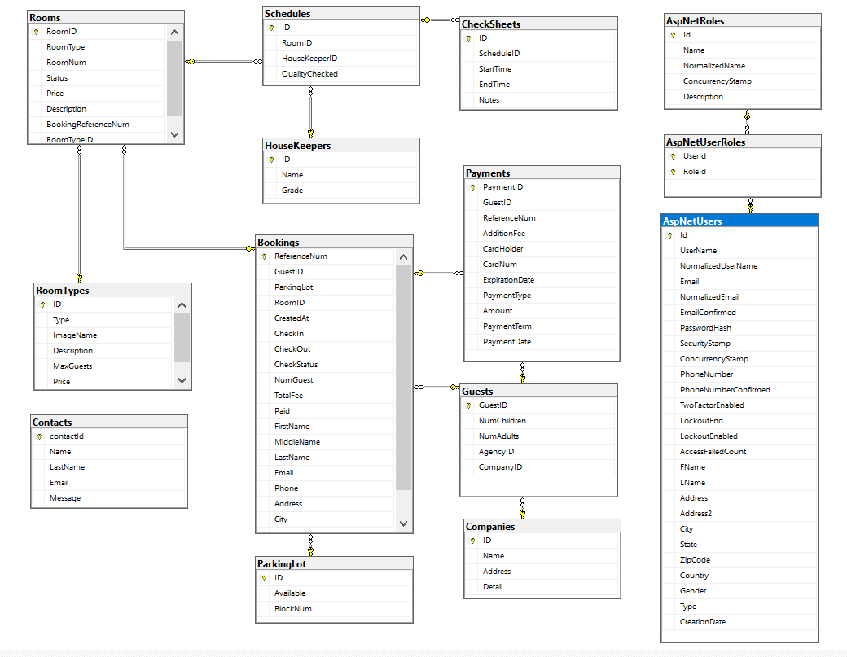

# Database Table

|  |
| --- |
| CREATE TABLE [dbo].[Bookings](  [ReferenceNum] [nvarchar](450) NOT NULL,  [GuestID] [nvarchar](450) NULL,  [ParkingLot] [bit] NOT NULL,  [RoomID] [nvarchar](max) NOT NULL,  [CreatedAt] [datetime2](7) NOT NULL,  [CheckIn] [datetime2](7) NOT NULL,  [CheckOut] [datetime2](7) NOT NULL,  [CheckStatus] [int] NOT NULL,  [NumGuest] [int] NOT NULL,  [TotalFee] [float] NOT NULL,  [Paid] [bit] NOT NULL,  [FirstName] [nvarchar](max) NOT NULL,  [MiddleName] [nvarchar](max) NULL,  [LastName] [nvarchar](max) NOT NULL,  [Email] [nvarchar](max) NOT NULL,  [Phone] [nvarchar](max) NULL,  [Address] [nvarchar](max) NULL,  [City] [nvarchar](max) NULL,  [Notes] [nvarchar](max) NULL,  [ParkingLotID] [nvarchar](450) NULL,  CONSTRAINT [PK_Bookings] PRIMARY KEY CLUSTERED  (  [ReferenceNum] ASC  )WITH (PAD_INDEX = OFF, STATISTICS_NORECOMPUTE = OFF, IGNORE_DUP_KEY = OFF, ALLOW_ROW_LOCKS = ON, ALLOW_PAGE_LOCKS = ON) ON [PRIMARY]  ) ON [PRIMARY] TEXTIMAGE_ON [PRIMARY] |

|  |
| --- |
| CREATE TABLE [dbo].[CheckSheets](  [ID] [nvarchar](450) NOT NULL,  [ScheduleID] [nvarchar](450) NULL,  [StartTime] [datetime2](7) NOT NULL,  [EndTime] [datetime2](7) NOT NULL,  [Notes] [nvarchar](max) NULL,  CONSTRAINT [PK_CheckSheets] PRIMARY KEY CLUSTERED  (  [ID] ASC  )WITH (PAD_INDEX = OFF, STATISTICS_NORECOMPUTE = OFF, IGNORE_DUP_KEY = OFF, ALLOW_ROW_LOCKS = ON, ALLOW_PAGE_LOCKS = ON) ON [PRIMARY]  ) ON [PRIMARY] TEXTIMAGE_ON [PRIMARY] |

|  |
| --- |
| CREATE TABLE [dbo].[Companies](  [ID] [nvarchar](450) NOT NULL,  [Name] [nvarchar](max) NOT NULL,  [Address] [nvarchar](max) NOT NULL,  [Detail] [nvarchar](max) NULL,  CONSTRAINT [PK_Companies] PRIMARY KEY CLUSTERED  (  [ID] ASC  )WITH (PAD_INDEX = OFF, STATISTICS_NORECOMPUTE = OFF, IGNORE_DUP_KEY = OFF, ALLOW_ROW_LOCKS = ON, ALLOW_PAGE_LOCKS = ON) ON [PRIMARY]  ) ON [PRIMARY] TEXTIMAGE_ON [PRIMARY] |

|  |
| --- |
| CREATE TABLE [dbo].[Contacts](  [contactId] [nvarchar](450) NOT NULL,  [Name] [nvarchar](max) NOT NULL,  [LastName] [nvarchar](max) NOT NULL,  [Email] [nvarchar](max) NOT NULL,  [Message] [nvarchar](max) NOT NULL,  CONSTRAINT [PK_Contacts] PRIMARY KEY CLUSTERED  (  [contactId] ASC  )WITH (PAD_INDEX = OFF, STATISTICS_NORECOMPUTE = OFF, IGNORE_DUP_KEY = OFF, ALLOW_ROW_LOCKS = ON, ALLOW_PAGE_LOCKS = ON) ON [PRIMARY]  ) ON [PRIMARY] TEXTIMAGE_ON [PRIMARY] |

|  |
| --- |
| CREATE TABLE [dbo].[HouseKeepers](  [ID] [nvarchar](450) NOT NULL,  [Name] [nvarchar](max) NOT NULL,  [Grade] [nvarchar](max) NOT NULL,  CONSTRAINT [PK_HouseKeepers] PRIMARY KEY CLUSTERED  (  [ID] ASC  )WITH (PAD_INDEX = OFF, STATISTICS_NORECOMPUTE = OFF, IGNORE_DUP_KEY = OFF, ALLOW_ROW_LOCKS = ON, ALLOW_PAGE_LOCKS = ON) ON [PRIMARY]  ) ON [PRIMARY] TEXTIMAGE_ON [PRIMARY] |

|  |
| --- |
| CREATE TABLE [dbo].[ParkingLot](  [ID] [nvarchar](450) NOT NULL,  [Available] [bit] NOT NULL,  [BlockNum] [nvarchar](max) NOT NULL,  CONSTRAINT [PK_ParkingLot] PRIMARY KEY CLUSTERED  (  [ID] ASC  )WITH (PAD_INDEX = OFF, STATISTICS_NORECOMPUTE = OFF, IGNORE_DUP_KEY = OFF, ALLOW_ROW_LOCKS = ON, ALLOW_PAGE_LOCKS = ON) ON [PRIMARY]  ) ON [PRIMARY] TEXTIMAGE_ON [PRIMARY] |

|  |
| --- |
| CREATE TABLE [dbo].[Payments](  [PaymentID] [nvarchar](450) NOT NULL,  [GuestID] [nvarchar](450) NULL,  [ReferenceNum] [nvarchar](450) NULL,  [AdditionFee] [int] NOT NULL,  [CardHolder] [nvarchar](max) NOT NULL,  [CardNum] [nvarchar](max) NOT NULL,  [ExpirationDate] [datetime2](7) NOT NULL,  [PaymentType] [int] NOT NULL,  [Amount] [float] NOT NULL,  [PaymentTerm] [nvarchar](max) NOT NULL,  [PaymentDate] [datetime2](7) NOT NULL,  CONSTRAINT [PK_Payments] PRIMARY KEY CLUSTERED  (  [PaymentID] ASC  )WITH (PAD_INDEX = OFF, STATISTICS_NORECOMPUTE = OFF, IGNORE_DUP_KEY = OFF, ALLOW_ROW_LOCKS = ON, ALLOW_PAGE_LOCKS = ON) ON [PRIMARY]  ) ON [PRIMARY] TEXTIMAGE_ON [PRIMARY] |

|  |
| --- |
| CREATE TABLE [dbo].[Rooms](  [RoomID] [nvarchar](450) NOT NULL,  [RoomType] [int] NOT NULL,  [RoomNum] [nvarchar](max) NOT NULL,  [Status] [int] NOT NULL,  [Price] [float] NOT NULL,  [Description] [nvarchar](max) NULL,  [BookingReferenceNum] [nvarchar](450) NULL,  [RoomTypeID] [nvarchar](450) NULL,  CONSTRAINT [PK_Rooms] PRIMARY KEY CLUSTERED  (  [RoomID] ASC  )WITH (PAD_INDEX = OFF, STATISTICS_NORECOMPUTE = OFF, IGNORE_DUP_KEY = OFF, ALLOW_ROW_LOCKS = ON, ALLOW_PAGE_LOCKS = ON) ON [PRIMARY]  ) ON [PRIMARY] TEXTIMAGE_ON [PRIMARY] |

|  |
| --- |
| CREATE TABLE [dbo].[RoomTypes](  [ID] [nvarchar](450) NOT NULL,  [Type] [int] NOT NULL,  [ImageName] [nvarchar](max) NULL,  [Description] [nvarchar](max) NULL,  [MaxGuests] [int] NOT NULL,  [Price] [int] NOT NULL,  CONSTRAINT [PK_RoomTypes] PRIMARY KEY CLUSTERED  (  [ID] ASC  )WITH (PAD_INDEX = OFF, STATISTICS_NORECOMPUTE = OFF, IGNORE_DUP_KEY = OFF, ALLOW_ROW_LOCKS = ON, ALLOW_PAGE_LOCKS = ON) ON [PRIMARY]  ) ON [PRIMARY] TEXTIMAGE_ON [PRIMARY] |

|  |
| --- |
| CREATE TABLE [dbo].[AspNetRoles](  [Id] [nvarchar](450) NOT NULL,  [Name] [nvarchar](256) NULL,  [NormalizedName] [nvarchar](256) NULL,  [ConcurrencyStamp] [nvarchar](max) NULL,  [Description] [nvarchar](max) NULL,  CONSTRAINT [PK_AspNetRoles] PRIMARY KEY CLUSTERED  (  [Id] ASC  )WITH (PAD_INDEX = OFF, STATISTICS_NORECOMPUTE = OFF, IGNORE_DUP_KEY = OFF, ALLOW_ROW_LOCKS = ON, ALLOW_PAGE_LOCKS = ON) ON [PRIMARY]  ) ON [PRIMARY] TEXTIMAGE_ON [PRIMARY] |

|  |
| --- |
| CREATE TABLE [dbo].[AspNetUsers](  [Id] [nvarchar](450) NOT NULL,  [UserName] [nvarchar](256) NULL,  [NormalizedUserName] [nvarchar](256) NULL,  [Email] [nvarchar](256) NULL,  [NormalizedEmail] [nvarchar](256) NULL,  [EmailConfirmed] [bit] NOT NULL,  [PasswordHash] [nvarchar](max) NULL,  [SecurityStamp] [nvarchar](max) NULL,  [ConcurrencyStamp] [nvarchar](max) NULL,  [PhoneNumber] [nvarchar](max) NULL,  [PhoneNumberConfirmed] [bit] NOT NULL,  [TwoFactorEnabled] [bit] NOT NULL,  [LockoutEnd] [datetimeoffset](7) NULL,  [LockoutEnabled] [bit] NOT NULL,  [AccessFailedCount] [int] NOT NULL,  [FName] [nvarchar](max) NULL,  [LName] [nvarchar](max) NULL,  [Address] [nvarchar](max) NULL,  [Address2] [nvarchar](max) NULL,  [City] [nvarchar](max) NULL,  [State] [nvarchar](max) NULL,  [ZipCode] [nvarchar](max) NULL,  [Country] [nvarchar](max) NULL,  [Gender] [nvarchar](max) NULL,  [Type] [nvarchar](max) NULL,  [CreationDate] [datetime2](7) NOT NULL,  CONSTRAINT [PK_AspNetUsers] PRIMARY KEY CLUSTERED  (  [Id] ASC  )WITH (PAD_INDEX = OFF, STATISTICS_NORECOMPUTE = OFF, IGNORE_DUP_KEY = OFF, ALLOW_ROW_LOCKS = ON, ALLOW_PAGE_LOCKS = ON) ON [PRIMARY]  ) ON [PRIMARY] TEXTIMAGE_ON [PRIMARY] |

|  |
| --- |
| CREATE TABLE [dbo].[AspNetUserRoles](  [UserId] [nvarchar](450) NOT NULL,  [RoleId] [nvarchar](450) NOT NULL,  CONSTRAINT [PK_AspNetUserRoles] PRIMARY KEY CLUSTERED  (  [UserId] ASC,  [RoleId] ASC  )WITH (PAD_INDEX = OFF, STATISTICS_NORECOMPUTE = OFF, IGNORE_DUP_KEY = OFF, ALLOW_ROW_LOCKS = ON, ALLOW_PAGE_LOCKS = ON) ON [PRIMARY]  ) ON [PRIMARY] |

# Web application demo